Annex 4. Reporting to IAIT – Checklist for partners under the CSO-strategy

Create an account/sign in to your existing account via the link; IATI Publisher and follow the instructions from IATI.
Please follow this checklist step by step and only report on the things mentioned below.

Table of Contents
CHAPTER ONE 2

STEP 1 – Create a report in IATI (first time) 2

STEP 2 – Download your report in XLSX-format and send it to your programme manager at Sida 5

STEP 3 – Reporting on sensitive information (only relevant if you have an agreement about this with your programme manager at Sida) 6

STEP 4 – Optional: How to complete your report in excel instead of doing it in IATI 7
CHAPTER TWO 8

Budget (current year) 8

Final Outcome (previous year) 8

CHAPTER ONE

STEP 1 – Create a report in IATI (first time)
Start by clicking on “Create Activity Manually” and then follow the steps below.
Stages 1-6 are default elements and will remain the same during the entirety of your project period.
Activity ID/identifier = SE-0-SE-6-contribution number (all parties in your report have the same activity ID)
The following elements are the ones we require you to use; you only need to fill in these exact elements with these exact instructions, nothing more and nothing less.
For your information; the first time you create a report in IATI will be the most extensive and time-demanding one. After that, all the reports you do will be an update on the already existing report in IATI, see CHAPTER TWO.
Fill in your elements accordingly through the column on the left side in your activity;
- Title = Project title (the same as in the agreement)
- Reporting Org = Your IATI reference code (which you receive when you create an account)
  - Name = Your organizations name
- Iati-identifier = Name of project (once you fill in the name of the project it should automatically generate your IATI identifier number – if not, you will find your IATI-identifier number in the e-mail you received when creating a new account)
- Description = Project/activity description
- Activity status = Implementation
- Activity date = Agreement period
- Region – (Only possible and sometimes necessary if you don’t allocate per region in the later steps since you can’t allocate region in both places. Some organisations have been unable to upload their report without doing this step if they haven’t allocated to regions in the later step. Therefore it is included in the routine for guidance if the same problem occurs to you. If you are unable to complete this step due to an error message in IATI, you may skip it.)
  - Fill in an estimate of what regions your activities take place in
- Participating-org = In all participating-orgs (except implementing) you must add the following information;
  - Role (Funding, Accountable or Implementing)
  - Reference (IATI reference code – you receive one when you create an IATI account)
  - Activity ID (all participants should have the same activity-id considering you are reporting under the same Sida contribution)
It should look like the example below;
Funding = Sida
    - Reference; SE-6
    - Activity ID; SE-0-SE-6-contribution number
Accountable = (You) Org name,
    - Reference; IATI-reference code
    - Activity ID; SE-0-SE-6-contribution number
Implementing = Your implementing partners
    - Activity ID; SE-0-SE-6-contribution number
Important to add all your implementing partners here!
- Budget = Total budget for the project per year (including own funds). You create a separate budget for each year.
  - On “Value date”, choose todays date.

- Transactions
All transactions need to have the provider activity ID.
  - Incoming funds = The received funds from Sida
    - Transaction type = Incoming funds
    - Transaction date = The day the transaction was made
    - Value = Total amount received from Sida (for instance the first amount received during 2026)
    - Description = “Sida disbursement nr x year xxxx” use this sentence and fill in the blanks according to your numbers (eg ”Sida disbursement nr 1 2026”)
    - Provider organisation;
      - Reference (Sida or Sida’s organisation identifier; SE-6),
      - Provider activity ID = SE-0-SE-6-contribution number
    - Receiver organisation;
      - Reference (your organisation or your organisation identifier)
      - Receiver activity ID = SE-0-SE-6-contribution number

  - Incoming commitment
Incoming commitment is where you allocate your funds by country and sector. Therefore you have to divide the funds according to your allocation and create one transaction per country/region.
    - Transaction type = Incoming commitment
    - Transaction date = Todays date
    - Value = The amount you wish to allocate to this specific country/region
    - Provider organisation;
      - Reference (Sida or Sida’s organisation identifier; SE-6),
      - Provider activity ID = SE-0-SE-6-contribution number
    - Receiver organisation;
      - Reference (your organisation or your organisation identifier)
      - Receiver activity ID = SE-0-SE-6-contribution number
    - Sector;
      - Vocabulary = 1 – OECD DAC CRS Purpose Codes 5 digit
      - Code = Your chosen sector
      - Narrative (percentage allocation on each sector). You add as many sectors as needed
    - Recipient country;
      - Code = Country
      - Narrative (percentage allocation)
    - Or/and Recipient region = Same as country
NOTE! The total allocation for all sectors should be 100%. The same with country/region, the total allocated funds for all transactions should equate to 100% and the total agreed Sida amount for that year.
- Example; if you have an agreed Sida budget of 10 000 000 SEK for 2026, all the allocated transactions to countries should add up to 10 000 000 SEK and the percentage should therefore be 100% since you are supposed to allocate 100% of the 10 000 000 SEK for 2026.
- You are supposed to allocate all costs, including administrative and costs in Sweden to the different countries.

The difference between Incoming funds and Incoming commitments;
- Incoming funds = The received funds from Sida, only use this once you have actually received the funds from Sida. No need for country and sector allocation and only used as a “receipt” of received funds.
- Incoming commitments = Planned incoming funds/preliminary outcome on transactions. We use this for you to be able to allocate your funds to countries and sectors. If you were to allocate your funds under “Incoming funds” you would only be able to allocate the already received funds and we need to be able to see an allocation on all planned funds.

  - Disbursement = should reflect either actual payments made to the implementing partner or, where relevant, the total costs booked and attributed to the implementing partner during the reporting period.

    - Reference = Implementing partners name
    - Transaction type = Disbursement
    - Transaction date = The date the transaction was made
    - Value = The amount disbursed to your implementing partner
    - Description = Total budget xxx (your implementing partner)
    - Provider organisation;
      - Organisation Identifier code (your organisation or your organisation identifier),
      - Provider activity ID = SE-0-SE-6-contribution number
    - Receiver organisation;
      - Receiver activity ID = SE-0-SE-6-contribution number
Disbursements are reported once per year in IATI – please report this during the Final Outcome report.
If you have many partners and a lot of different disbursements, you may report each partners total disbursed amount for the entire year. It will then be one disbursement per partner each year.

STEP 2 – Download your report in XLSX-format and send it to your programme manager at Sida
- Go to “Activity data”
- Select the activity data you wish to download
- Download XLSX
See picture below with stage 1-3.
  - Only the excel called “Activity” is relevant. See STEP 3, 2.b below for advice on how to more easily navigate the excel.
  - You only need to look at the elements already reported on, the blank element are irrelevant.
- Once downloaded, send the excel called “Activity” to your programme manager at Sida (for now you will have to send it via E-mail, we are working on solutions where this step might look different in the future).
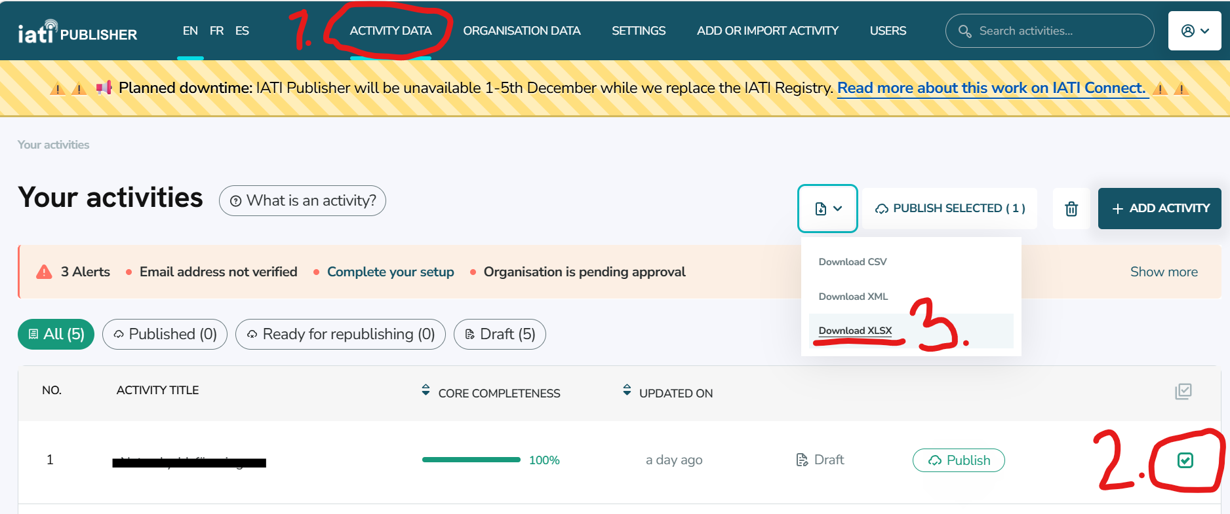
- After your report has been approved by your programme manager, go to IATI and select your activity (like step number 2 in the picture) and press Publish.

STEP 3 – Reporting on sensitive information (only relevant if you have an agreement about this with your programme manager at Sida)
- Fill in all default elements (stage 1-6), element 8 (Participating org), element 9 (Budget) and 10 (Transactions).
  - If possible, fill in all sections in element 8 (Participating org). If, due to safety concerns, you are unable to fill in all your implementing partners, only fill in the implementing partners that can be published online.
  - If in element 10 Transactions – Incoming commitments, you are unable to allocate your funds to specific countries or sectors, please allocate in region instead or skip this step completely and only report on your incoming commitments without allocating it to a sector or country/region (there will be an opportunity to do this in the next step). However, even if some countries are considered sensitive information, it is still required to allocate to those countries who are not considered sensitive in IATI. For example, if country X is safe to report directly in IATI but country Y is not, then you report country X and report country Y in the later step.
  - If in element 10 Transactions – Disbursements, you are unable to publish information on all your disbursements to your partners due to safety reasons, please only publish the ones that are safe for public viewing. You will report the remaining partners in the next step.
- Once you have finished filling in the elements above where possible, follow STEP 2 and download your report in XLSX-format.
  - Once downloaded, open the excel called “activity” – here your are able to complete your report with the information that was not possible to be uploaded in IATI.
  - In the excel, to easier navigate it, go to “View” “Navigation”. By doing this you will se the elements in a list form instead of down at the bottom of the document.
- Go to element “Participating org” and fill in your implementing partners the same way you filled in Funding and Accountable org.
- Go to element “Transaction” and the Transaction that says “Incoming commitment”. Go to step 11b and follow the instructions in this manual, then go to the excel and fill in your sector and country allocation in column V-AB. Allocate by percentage under the Sector och Country Narrative section.
- In the same element as above, fill in your remaining Disbursements in the excel together with the other disbursements.
- Once you have finished filling in all the required elements in the excel, follow STEP 2 stage 4 and 5, and send the excel to your Programme manager at Sida.

STEP 4 – Optional: How to complete your report in excel instead of doing it in IATI
Might be easier for those who have multiple transactions and participating organisations.
When you need to report on multiple items within the same element – for example, as you do in ‘Transactions’ – it may be easier to complete all the elements once within IATI; for instance, you could complete an ‘incoming funds’, an ‘incoming commitment’ and a ‘disbursement’, and follow this approach for all the mandatory steps mentioned in the checklist. Then download the Excel file from IATI following STEP 2, and continue working there, filling in the remaining information in the same way as described in steps 2 and 3b.
Once you have filled in all the information in the Excel file, send it to your programme manager at Sida for approval. Once you have received confirmation that the report has been approved, you can then upload the entire Excel file to IATI, and all the information will be entered into IATI. In that case, proceed as follows:
- Click on ‘Add activity’ in the top right-hand corner in IATI under your activities
- Import activities from XLSX
- Select ‘Basic Activity Elements’ and upload your completed Excel file –> Upload file
- Once the file has been uploaded, tick the small box to the right of it and click on ‘ADD’ in the top right-hand corner
- Then follow step 2.5 and publish the report on IATI
If you find it easier to work directly in IATI, you can do that instead; this is simply an alternative method which I suspect may be easier for many people who already work in Excel, as they can then copy the information to be used directly from their own files into the IATI Excel template.

CHAPTER TWO
The information mentioned below is what you will need to update during the different reporting periods throughout the year. Note, once you have updated the required elements, follow STEP 2 in CHAPTER ONE.
Incoming Funds & Disbursements are however entered only during the Final Outcome report.
- For your exact reporting period, please see your agreement or consult with your programme manager at Sida.

Please remember, every time you update the information you will need to repeat STEP 2 in CHAPTER ONE.
In the excel sheet:

Budget (current year)
- Budget – if there have been any changes to the budget
- Recipient Region – if applicable
- Transaction
  - Incoming Commitment
  - W – Sector code – Sector
  - Y - Sector Narrative: Sector allocation as a percentage
  - AA – Recipient Country Code: Programme countries
  - AB – Recipient Country Narrative: Country allocation as a percentage
  - AE – Recipient region: 998 developing countries, unspecified
  - AG – Recipient Region Narrative: Percentage allocation of code 998 and/or region

Final Outcome (previous year)
If needed, update all values below to the actual outcome, then proceed to STEP 2 in CHAPTER ONE.
- Budget – if there have been any changes to the budget
- Recipient Region – if applicable
- Transaction
- Incoming Funds - enter all incoming funds for the previous fiscal year
- Disbursements - enter all incoming funds for the previous fiscal year
- Incoming Commitment
- W – Sector code – Sector
- Y - Sector Narrative: Sector allocation as a percentage
- AA – Recipient Country Code: Programme countries
- AB – Recipient Country Narrative: Country allocation as a percentage
- AE – Recipient region: 998 developing countries, unspecified
- AG – Recipient Region Narrative: Percentage allocation of code 998 and/or region

